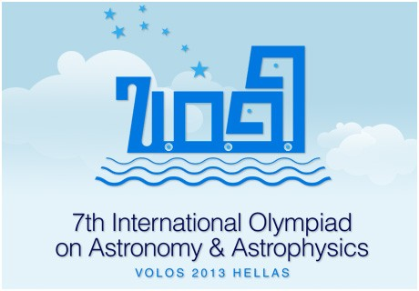

THE TELESCOPE OF THE 7TH INTERNATIONAL OLYMPIAD ON ASTRONOMY & ASTROPHYSICS

SkyWatcher 150/750 Black Diamond EQ3-2

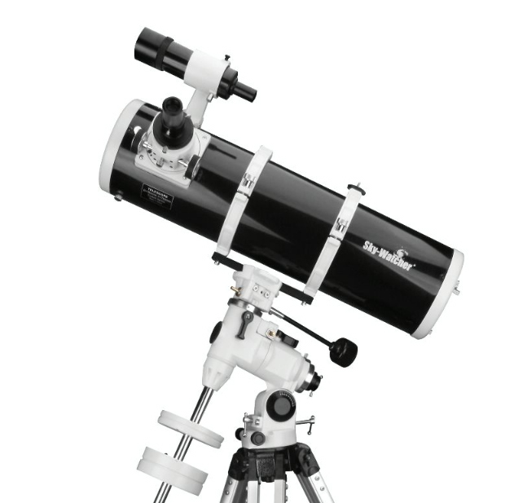

SPECIFICATIONS
The telescope of the 7th International Olympiad on Astronomy & Astrophysics will be a Newtonian reflector telescope on equatorial mount, constructed by the SkyWatcher company. The parabolic mirror has a diameter D = 150mm (5.91"), with a focal length F = 750mm (29.5") and a focal ratio of f/5.

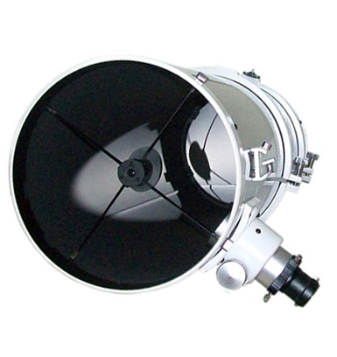

The secondary mirror is mounted on a spider metal blades, with a thickness of 0.5mm. The focuser of the telescope is type ‘’rack and pinion’’. Will be used with adapter of 31.8mm (1.25 ").
The dimensions of the tube is 18cm (diameter)× 65 (height). The weight of the tube is 4.93 Kg.

On the tube a simple achromatic 6x30 finder (with inverted image!) is adapted. The alignment of the finder is achieved with 2 plastic screws.
The telescope tube is connected on the equatorial mount EQ3-2 of SkyWatcher, which has 2 knobs for manual movement in RA and Dec and calibrated position circles.
The transmission movement on both axes is done with a direct ''worm-gear’’ system. There is not clock drive system. The equatorial head is mounted on a tripod with aluminum legs with adjustable height (71–123 cm). The mount has a leveling bubble.

The 2 eyepieces of Ø31.8mm (1.25 ") are supplied:
A) SUPER Plossl 25mm (30×) WA, LE
B) SUPER Plossl 10mm (75×)
A 2×, 31.7mm (1.25″) achromatic Barlow lens will also be provided.

SUMMARY
Type: Reflector telescope
Optical design: Newtonian
Diameter: 150 mm (5.91″) (parabolic)
Focal length: F 750 mm
Focal Ratio: f / 5
Focuser: rack and pinion type.
Mount: EQ3-2 Equatorial with 2 knobs for manual movement in RA and Dec and calibrated position circles.
Tripod: Aluminum legs with adjustable height (71–123 cm) and leveling bubble.
Finder: 6×30 (with inverted image)
Alignment: Built in Polar Alignment Scope Holder
Eyepieces: SUPER Plossl 25mm (30×) WA, LE and SUPER Plossl 10mm (75×), Ø31.8mm
Barlow: 2×, achromatic
Maximum Usable Magnification: 300 ×
Minimum Star Magnitude Size: m_{V} = 13.6
Theoretical Resolution: 0.8 arc sec

ADDITIONAL FEATURES
• dimensions of tube: 18 × 65 cm
• Weight of tube: 4.93 Kg
• Stand with feet aluminum folding
• 2 counterweights (weight 5.2 kg total)

