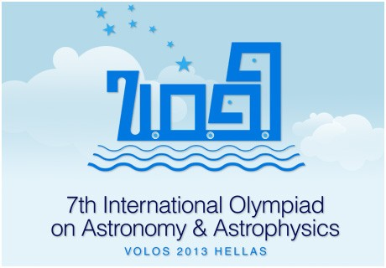

THE TELESCOPE OF THE 7TH INTERNATIONAL OLYMPIAD ON ASTRONOMY & ASTROPHYSICS

SkyWatcher 150/750 Black Diamond EQ3-2

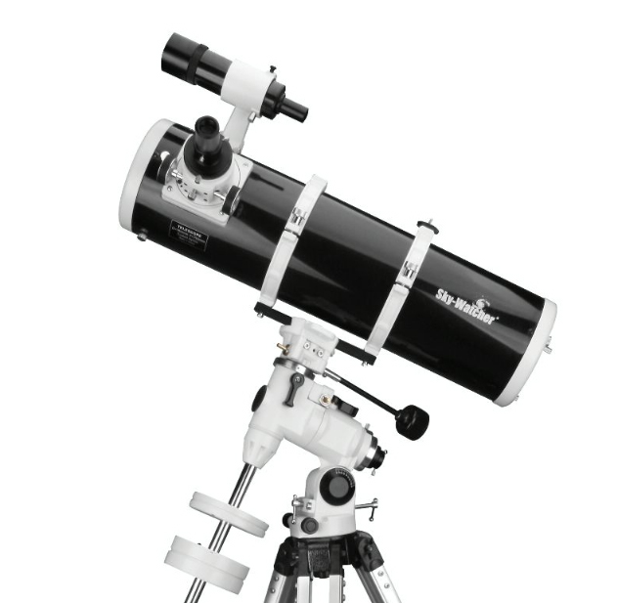

SPECIFICATIONS
The telescope of the 7th International Olympiad on Astronomy & Astrophysics was chosen as the Newtonian reflector telescope on equatorial mount, constructed by the company SkyWatcher. The parabolic mirror has diameter D = 150mm (5.91"), with a focal length F = 750mm (29.5") and a focal ratio of f/5.

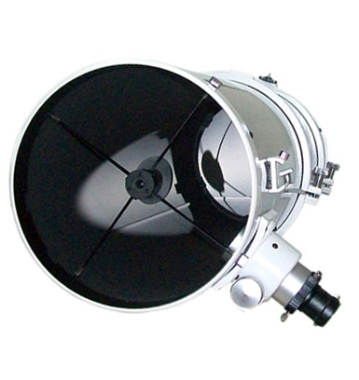

The secondary mirror is mounted on a spider metal blades, having a thickness of 0.5mm. The focuser of the telescope is type ‘’rack and pinion’’. Will be used with adapter of 31.8mm (1.25 ").
The dimensions of the tube is 18cm (diameter)X 65 (height). The weight of tube is 4.93 Kg.

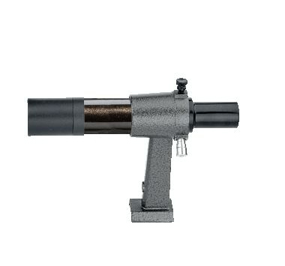
On the tube is adapted a simple achromatic 6x30 finder (no erect!). The align of the finder is done with 2 plastic screws.
The tube will connected on the equatorial mount EQ3-2 of SkyWatcher, which has 2 knobs for manual movement in RA and Dec and calibrated position circles.
The transmission movement on both axes is done with the direct ''worm-gear’’ system. There is not clock drive system. The equatorial head is mounted on a tripod with aluminum legs with adjustable height (71-123 cm). The mount has a leveling bubble.

The 2 eyepieces of Ø31.8mm (1.25 ") supplied:
A) SUPER Plossl 25mm (30x) WA, LE
B) SUPER Plossl 10mm (75x)
It will also provide a 2X, 31.7mm (1.25 ") achromatic barlow lens.

SUMMARY LIST OF CHARACTERISTICS
OF THE 7TH INTERNTIONAL OLYMPIAD on ASTRONOMY & ASTROPHYSICS TELESCOPE
Type: Reflector
Optical design: Newtonian
Diameter: 150 mm (5.91 ") (parabolic)
Focal length: F 750 mm
Focal Ratio: f / 5
Mount: EQ3-2 Equatorial
Finder: 6x30
Eyepieces: SUPER Plossl 25mm (30x) WA, LE and SUPER Plossl 10mm (75x), Ø31.8mm
Barlow: 2x achromatic
Maximum Usable Magnification: 300 x
Minimum Star Magnitude Size: 13.6
Theoretical Resolution: 0.8 arc sec

ADDITIONAL FEATURES
• dimensions of tube: 18 x 65 cm
• Weight of tube: 4.93 Kg
• Stand with feet aluminum folding
• 2 counterweights (weight 5.2 Kg total)

